NNEDV Process for using Emergency FMLA and Emergency Paid Sick Leave
- If you have any questions about the paperwork/documentation/payroll process with regard to using leave under the new Families First Act, please reach out to Lara/Angie for assistance.
- Please see the NNEDV COVID-19 Emergency Paid Leave Benefit Policy for details on when you are eligible for both types of leave. This policy can be found in Dropbox (NNEDV)\NNEDV_Operations\00-Emergency Office Updates and Procedures.
- If you have symptoms of Coronavirus, please let your supervisor and the E-team know, and take Emergency Paid Sick Leave as needed. (your paperwork can be completed later or with help from your supervisor).
- If you need to take Emergency FMLA, please talk with your supervisor about your schedule first, and then complete the needed forms.
- Please complete the proper request forms for both types of leave. Both can be found in Dropbox (NNEDV)\NNEDV_Operations\00-Emergency Office Updates and Procedures.
- You or your supervisor will need to let the Admin Team know that you are taking Emergency FMLA or Emergency Paid Sick Leave, so that we can properly record your hours in payroll. You do not need to submit your timesheet early, but we may need to check in with you to make sure we are recording the hours properly.
- Once you have taken leave, please record it on your timesheet in the Floating Holiday/Other row. Example below:
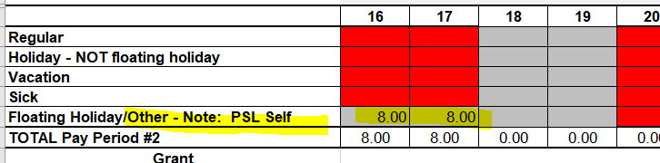
- To correspond with our Paycom codes, please put the following codes in the Other: Note for the various types of leave:
  - For the Emergency FMLA/Paid Family Leave, please put PFL
  - For the Emergency Paid Sick Leave for yourself, please put PSL Self
  - For the Emergency Paid Sick Leave to care for a family member, please put PSL Family

